Prairie Family Center &
Family Resource Center Association
JOIN US!!!!
VICTOR’S of
DOMESTIC
VIOLENCE 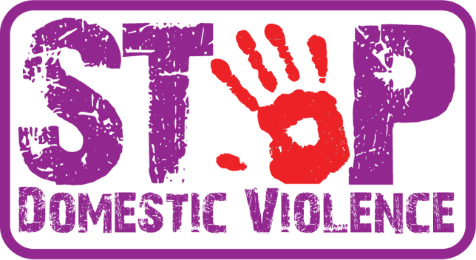
This Photo by Unknown Author is licensed under CC BY
We are not victims! Only victorious!
A domestic violence survivor support group
United Methodist Church of Burlington
290 13th St.
Burlington, CO
Beginning Sept. 5 | 530 p.m. to 630 p.m.
(for more information please contact Susan Sandoval at 719-346-5398)

